Geometry: Unit 3, Lesson 2

- $∠NSH$ and $∠KSW$ are vertical angles and the $m∠NSH=139°$. What is an equation that could be used to find the value of $m∠KSW$?

$$m∠KSW=139°$$

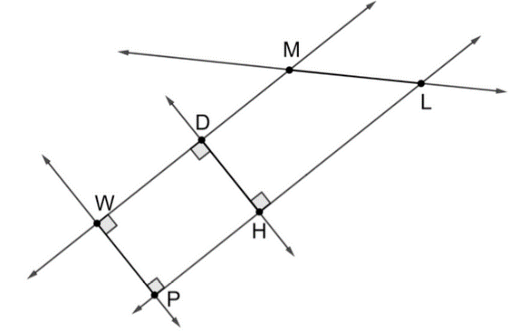
- Lines $WM$, $WP$, $ML$, $DH$, and $LH$ are shown. What line is a traversal of lines $WM$ and $LH$?

Line $ML$

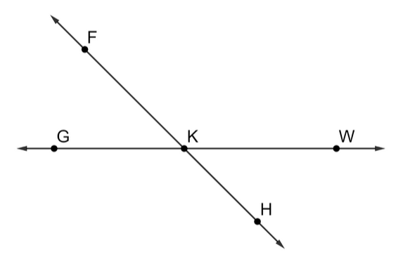
- Lines $FH$ and $WG$ intersecting at point $K$ are shown. What is an angle pair that has equal measures?

$∠WKH$ and $∠GKF$

